(Shane, Rachel) What is text normalization? / Compare bag-of-words, binary bag-of-words and TF-IDF.

Text normalization is the procress of transforming text into a canonical form it may not have had before.

Could involte:
* case changing – John → john
* removing accents – résumé → resume
* stemming/lemmatization (reducing a word to its base form) running → run,
<stem>argued, arguing, argue → argu (need not be a word)
<lemma> argued, arguing, argue → argue

stemming – follows a crude algorithm that changes parts of the word based on patterns
mapping: “ing” - > “” starting → start, ring→ r

lemmatizing – uses an algorthm based on the language to reduce words to a more basic structure:
starting → start; am, are, is → be

bag-of-words – counts occurrences of a word in a document

binary bag of words – marks if a word is present or not

tf-idf – term frequency-inverse document frequency – similar to bag of word, but word frequency is replaced by a weighting that accounts for word frequency and how rare the word is in the dataset

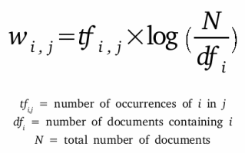

This will weight different words that appear the same number of times in a document based on how often the words appear in the whole dataset.

Example. Document 17 contains the words “taco” and “rabbit” 3 times.
There are 1400 documents in the data set and “taco” appears 570 times in the data set and “rabbit” appears 12 times in the data set.
word | Tf_{word, 17} | log(1400 / df_{word}) | W_{word, 17}
“taco” | 3 | 0.8986 | 2.696
“rabbit” | 3 | 4.7593 | 14.278

The more documents a word appears in, the less useful it is for a signal.

